**COMPUTER NETWORKS**

**CSA0718**

**PRACTICAL EXPERIMENTS**

* **NAME:-NAGA CHARANTEJA**
* **REG NO:192124177**

1. Configuration of Topologies using Packet Tracer (Star, Mesh, Tree,)
2. Configuration of Topologies using Packet Tracer (Bus, Ring, Hybrid
3. Data Link Layer Traffic Simulation using Packet Tracer Analysis of CSMA/CD& CSMA/CA
4. Data Link Layer Traffic Simulation using Packet Tracer Analysis of ARP
5. Static Routing using Packet Tracer
6. Dynamic Routing using Packet Tracer ( OSPF)
7. Subnetting – Class C Addressing
8. Functionalities of TCP, UDP
9. TCP, UDP Exploration Solution
10. IOT Based Smart Home Using Cisco Packet Tracer
11. Smart Garden in Cisco Packet Tracer
12. IOT Devices in Networking Using Cisco Packet Tracer
13. Simulating X,Y,Z Company Network Design
14. Make Computer Lab in
15. Cisco Packet Tracer

Experiment-1

**Configuration of Network Devices using Packet Tracer tools(Hub, Switch, Ethernet, Broadcast)**

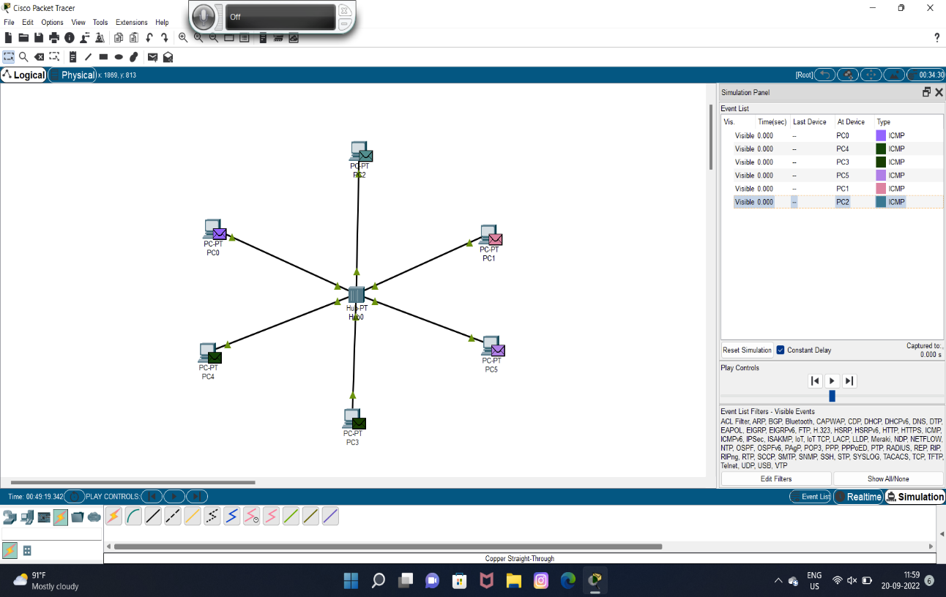

p. bhanu vardhan reddy

192110104

EXPERIMENT-2

**Configuration of Topologies using Packet Tracer (Star, Bus, Ring)**

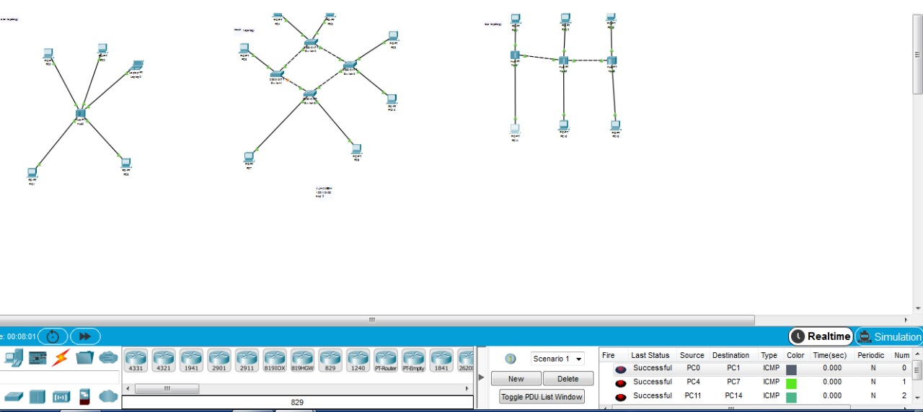

EXPERIMENT-3

**Configuration of Topologies using Packet Tracer (Mesh, Tree ,Hybrid)**

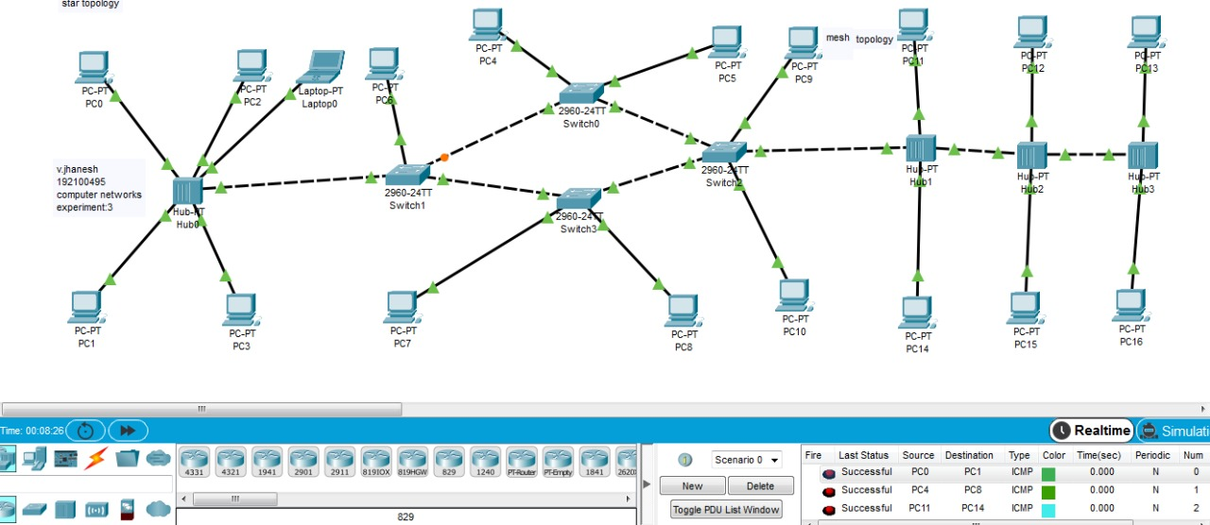

EXPERIMENT-4

**Data Link Layer Traffic Simulation using Packet Tracer Analysis of ARP**

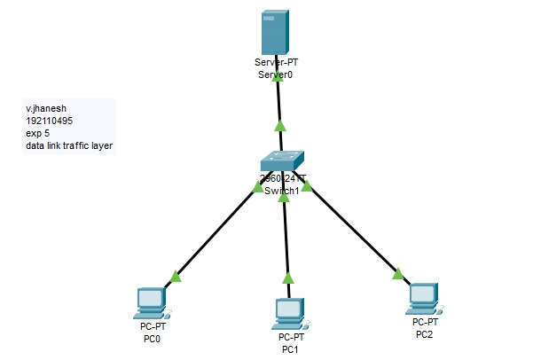

EXPERIMENT-5

**Data Link Layer Traffic Simulation using Packet Tracer Analysis of CSMA/CD& CSMA/CA**

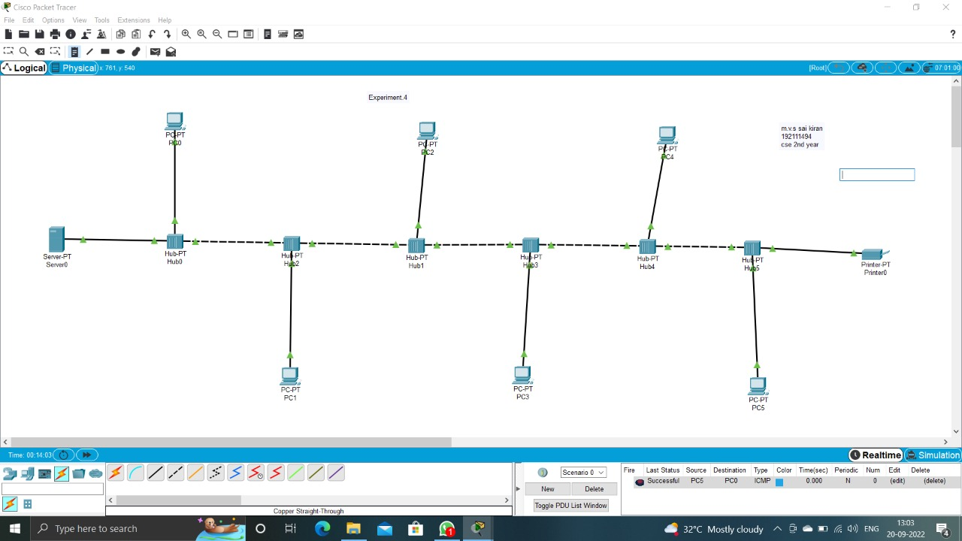

EXPERIMENT-6

**Static Routing using Packet Tracer**

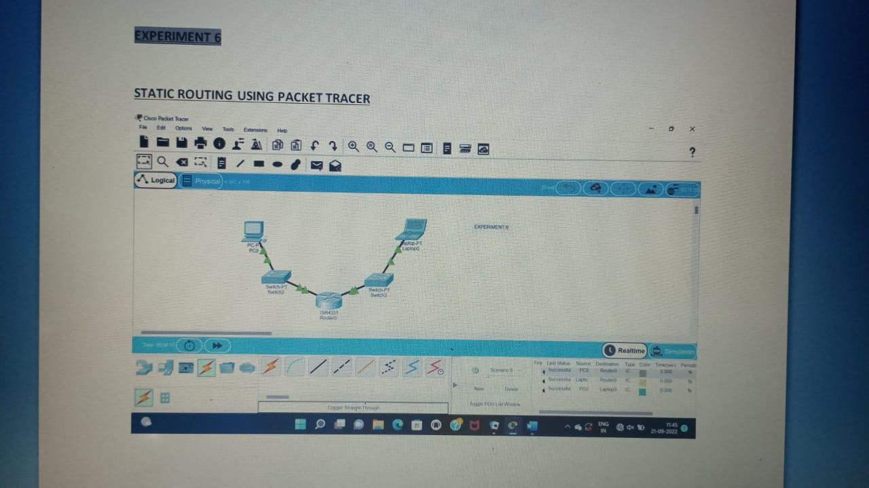

EXPERIMENT-7

**Dynamic Routing using Packet Tracer (Distance vector & OSPF)**

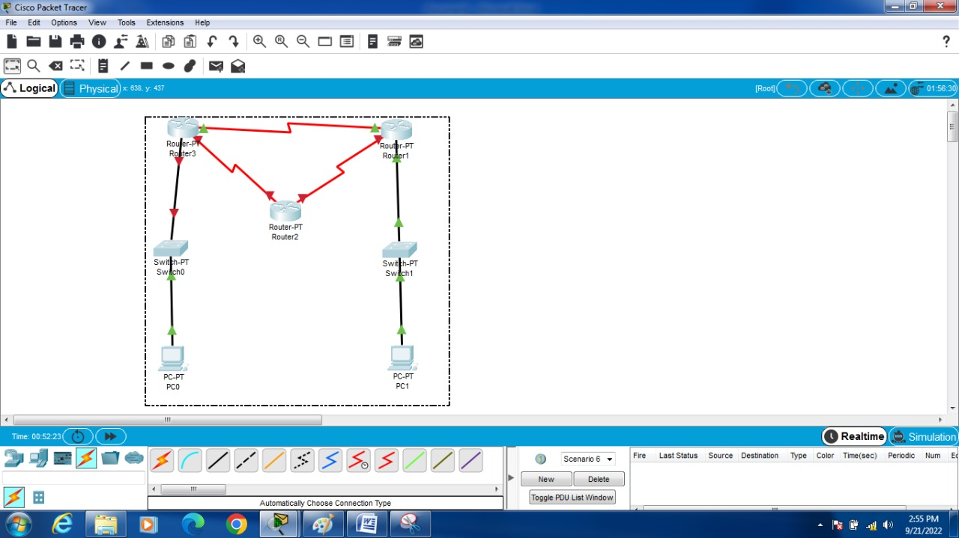

EXPERIMENT-8

**Functionalities of TCP, UDP**

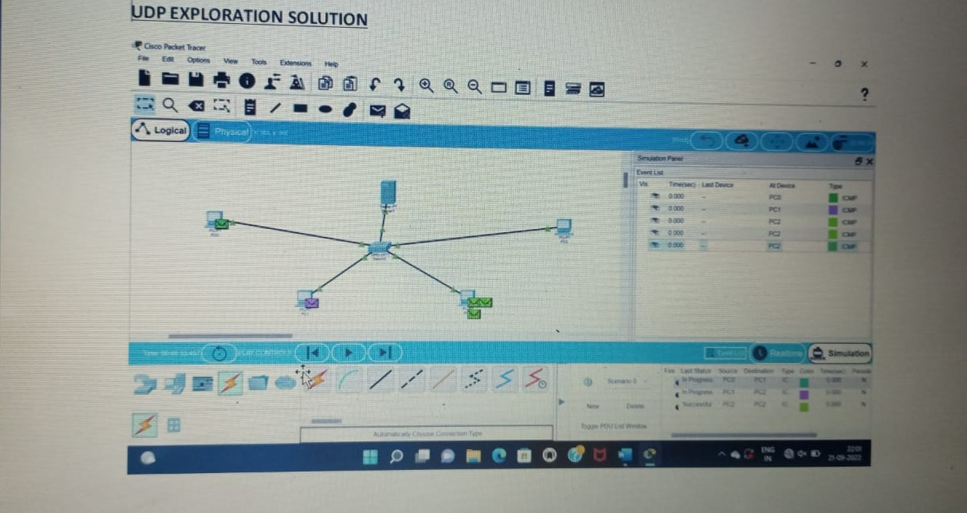

EXPERIMENT-9

**TCP, UDP Exploration Solution**



**EXPERIMENT-10**

**Subnetting – Class C Addressing**

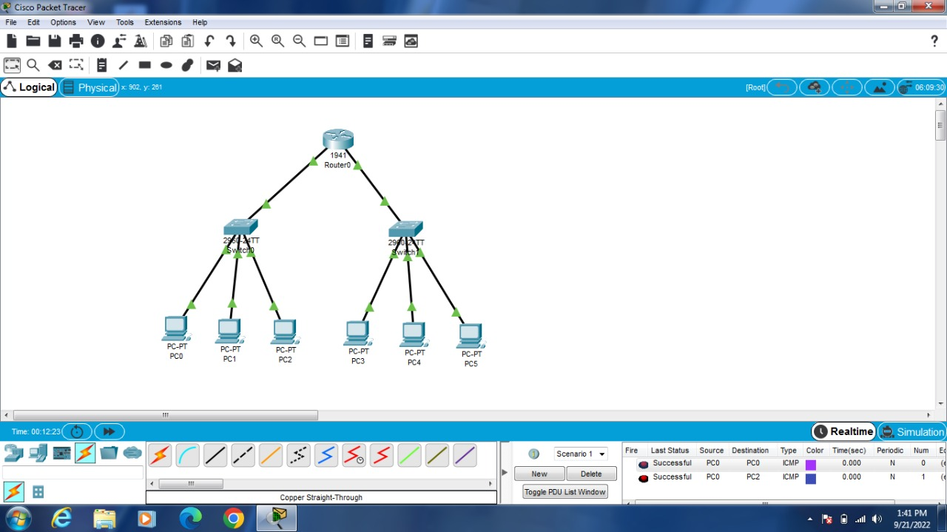

**EXPERIMENT-11**

**Simulating X, Y, Z Company Network Design**

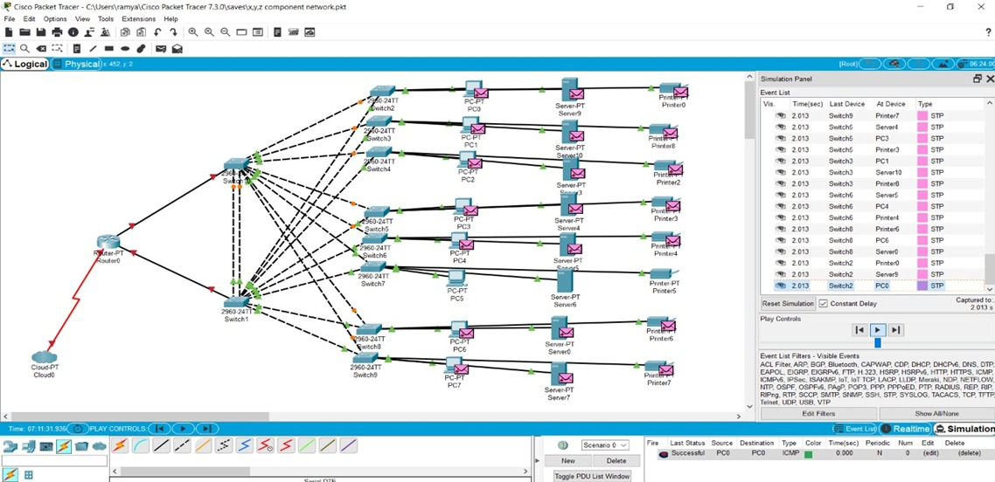

**EXPERIMENT-12**

**Smart Garden in Cisco Packet Tracer**

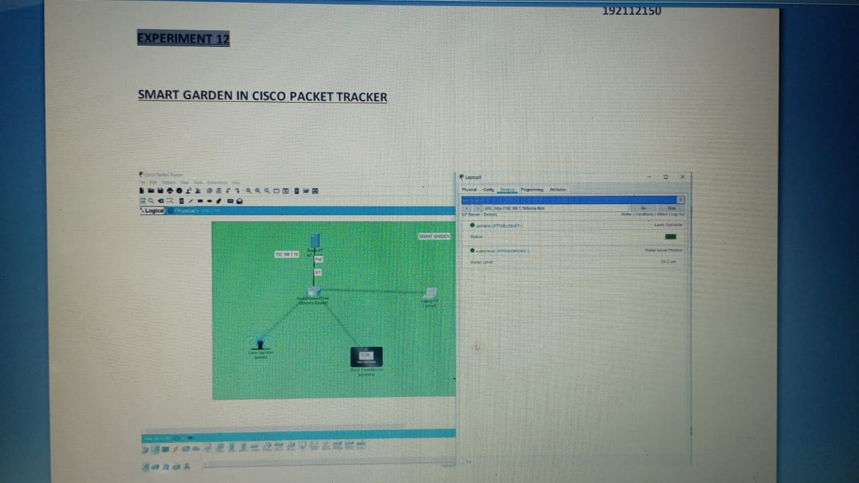

**EXPERIMENT-13**

**Smart Garden in Cisco Packet Tracer**

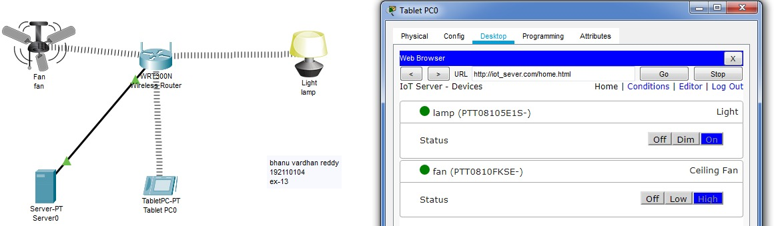

**EXPERIMENT-14**

**Smart Garden in Cisco Packet Tracer**



**EXPERIMENT-15**

**Make Computer Lab in Cisco Packet Tracer**

